Yunlu Li

STAT 5170

Homework 5

Question 1

(a) The ACP plot decays and PACF plot shows 0 correlation after lag 2. The plots match what we theoretically know about causal AR(2).

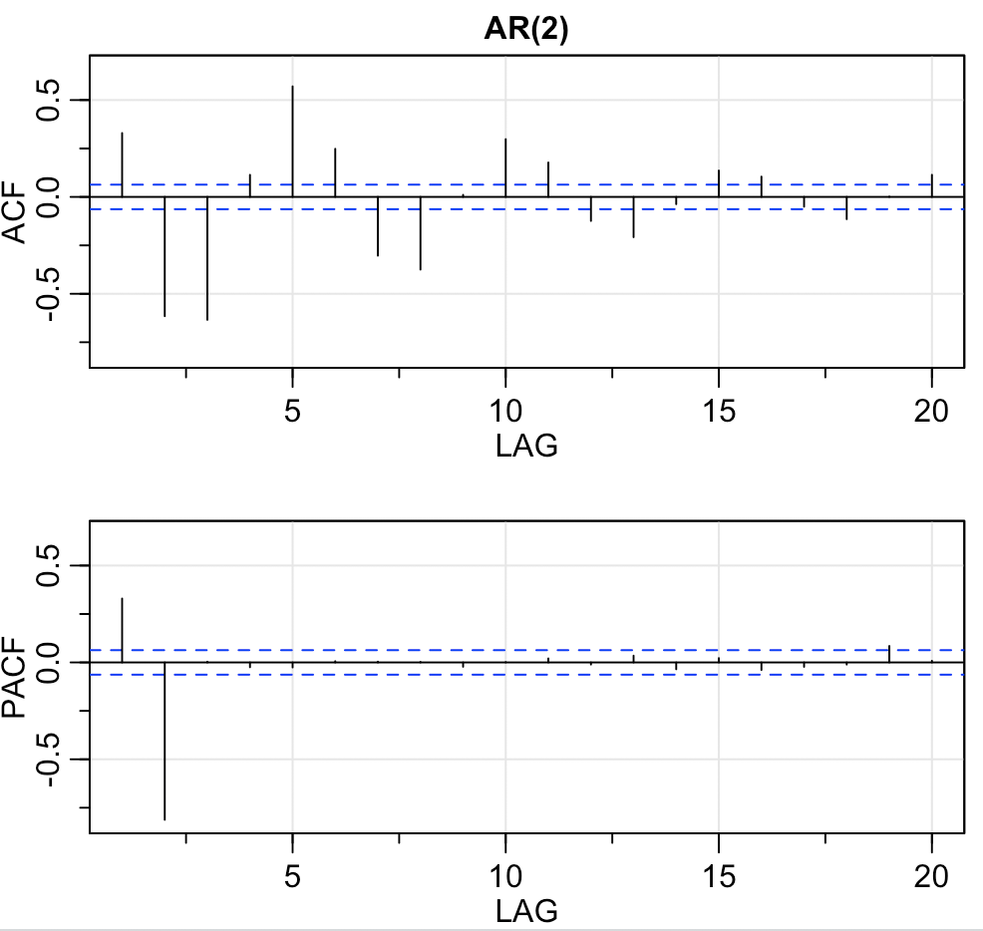

(b) The ACF plot shows 0 correlation after lag 2 and PACF plot decays. The plots match what we theoretically know about causal MA(2).

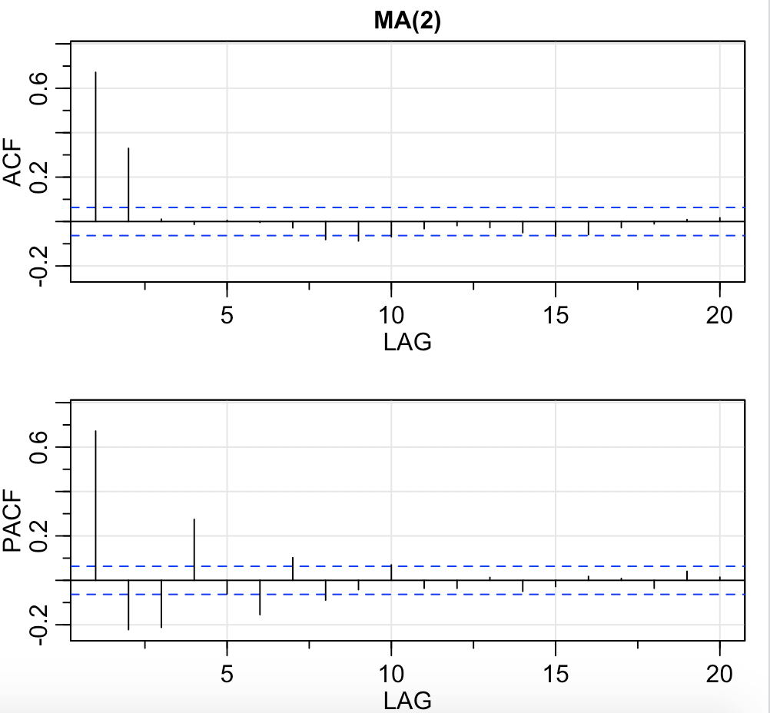

(c) The ACF plot and the PACF plot both decay. The plots match what we theoretically know about causal ARMA(1, 1).

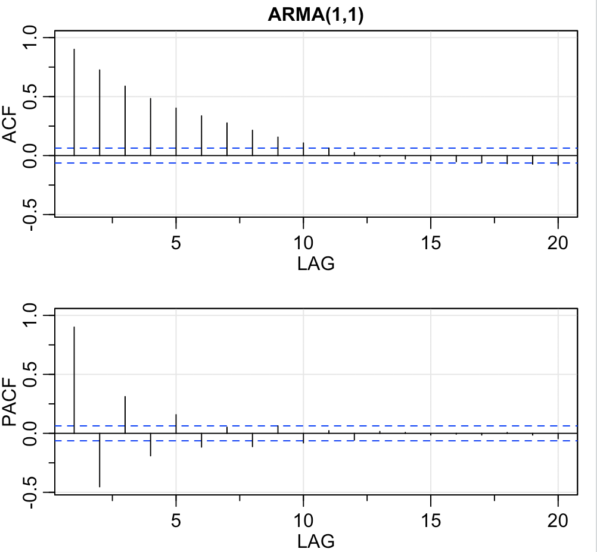

Question 2

(a) Both ACF plots and PACF plots decay, so I would suggest that both Berkeley and Santa Barbara are ARMA model.

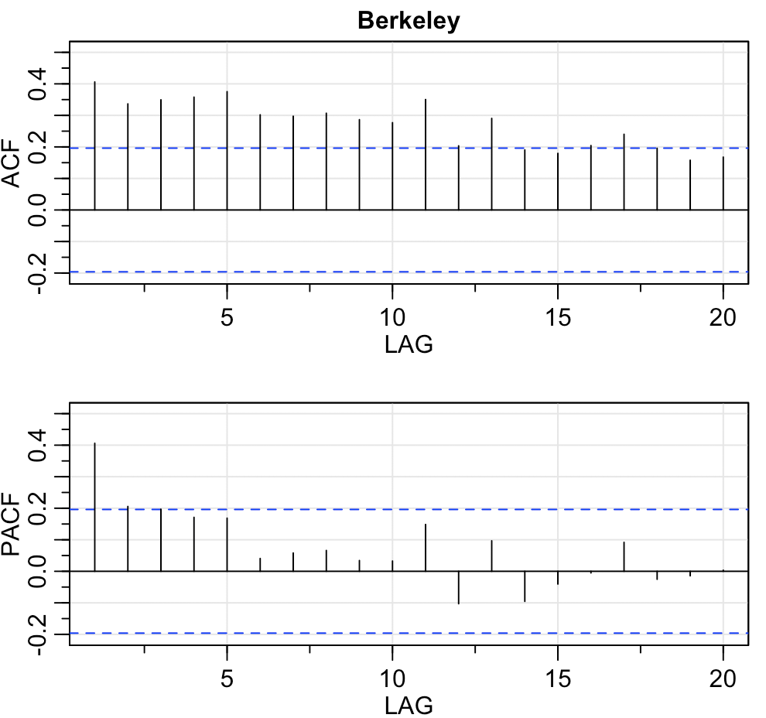 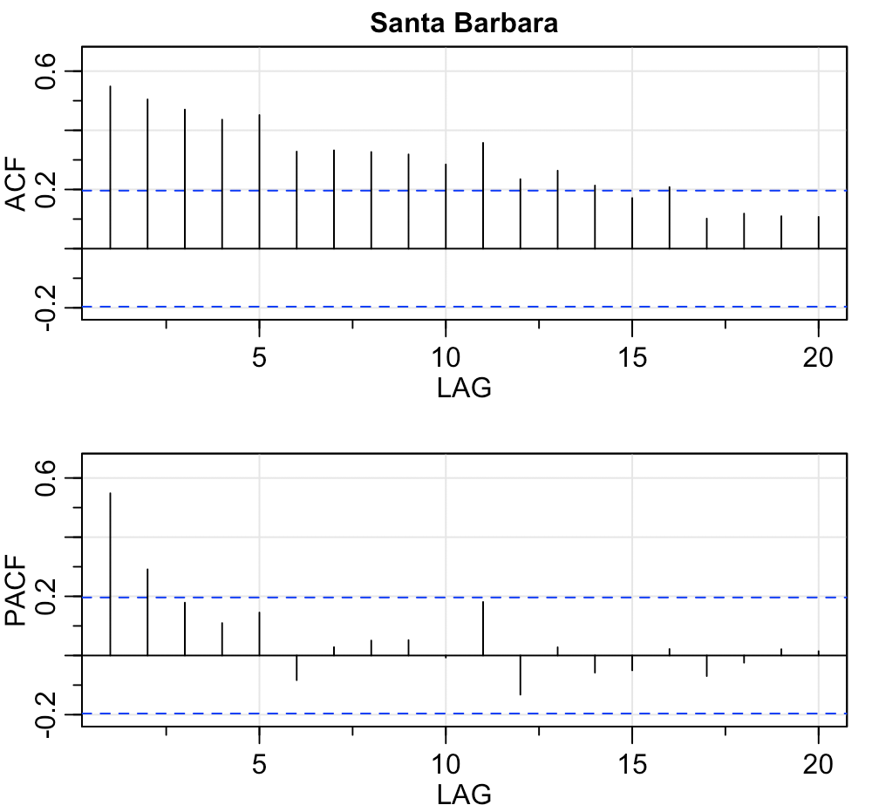

(b) Both differenced ACF plots show 0 correlatiobn after lag 1 and differenced PACF plots decays, so I would suggest that both Differenced Berkeley and Differenced Santa Barbara are MA(1) model.

